📘 Chapter 8 – Image Opacity: Transparent Ka Jadoo 🪄

🧊 What is Opacity in CSS?
opacity ek CSS property hai jo element (jaise image, div, text) ko transparent banane ke liye use hoti hai.
Jaise WhatsApp status pe sticker faint dikhte hain – waise hi CSS me image ya text halki dikhayi de sakti hai 😎

🎚️ Syntax:
opacity: value;
✅ Value range:
- 1 = Fully visible (no transparency)
- 0.5 = 50% transparent
- 0 = Fully invisible

🧪 Example 1 – Image with Opacity:
<img src="https://via.placeholder.com/200" style="opacity: 0.5;">
🧠 Result: Image thodi faint dikhegi – jaise uspar dhund ho 😶‍🌫️
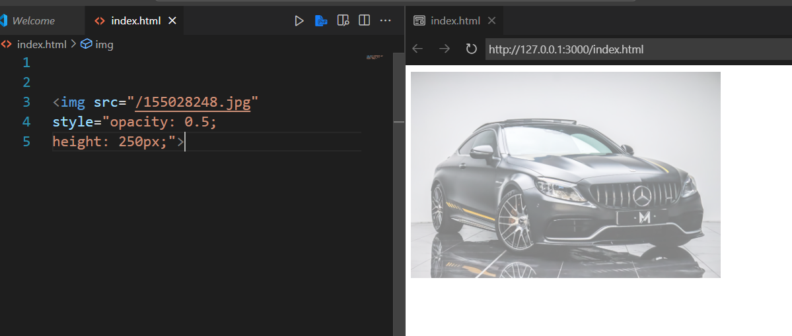

⚠️ Important Note:
opacity lagta hai poore element pe — text, background, border sab transparent ho jaata hai.

🔄 Kaam Chalu Karne Wali Trick – Transparent Sirf Background:
Agar sirf background transparent chahiye, aur content full dikhna chahiye toh rgba() ya hsla() use karo.

🧪 Example 2 – Transparent Background Only:
<div style="background-color: rgba(0, 0, 0, 0.3); color: white; padding: 20px;">
Bhai sirf background transparent hai, text full visible 😎
</div>

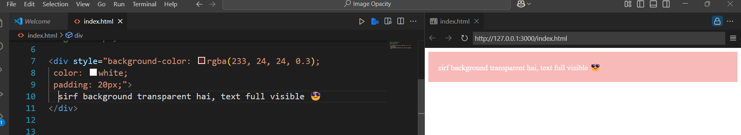
✅ rgba = red, green, blue, alpha (alpha = opacity)

🔍 Example 3 – Hover Pe Opacity Badalna (Stylish Effect)
<style>
img:hover {
opacity: 0.6;
}
</style>

<img src="https://via.placeholder.com/150">

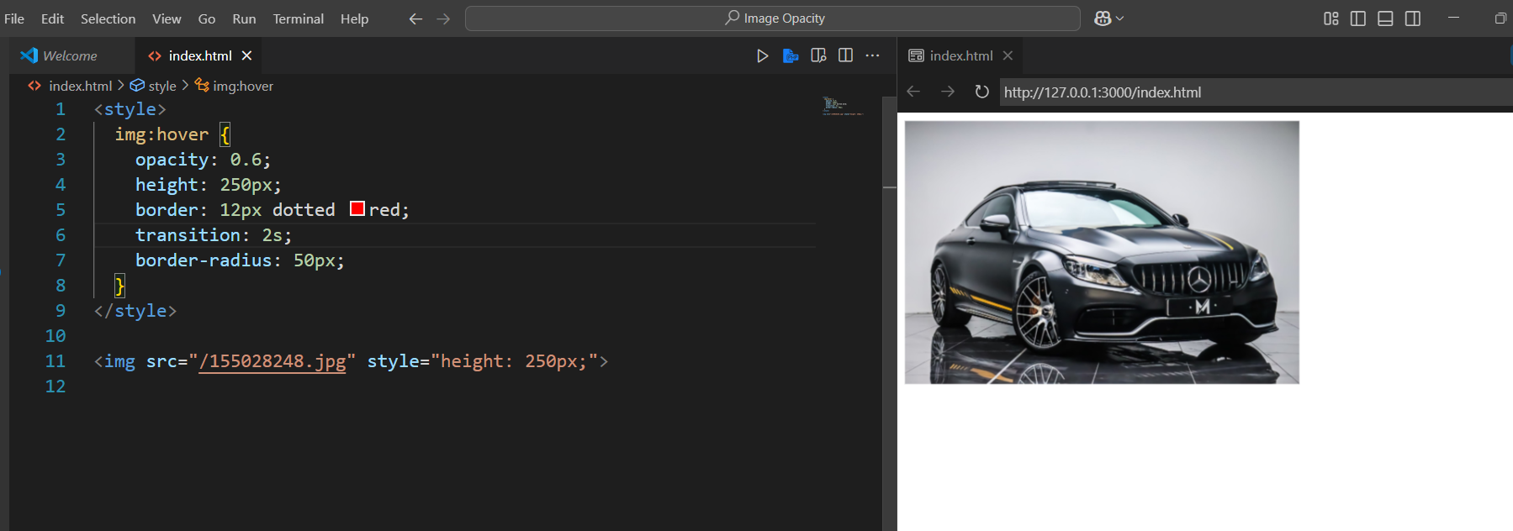

After Hover
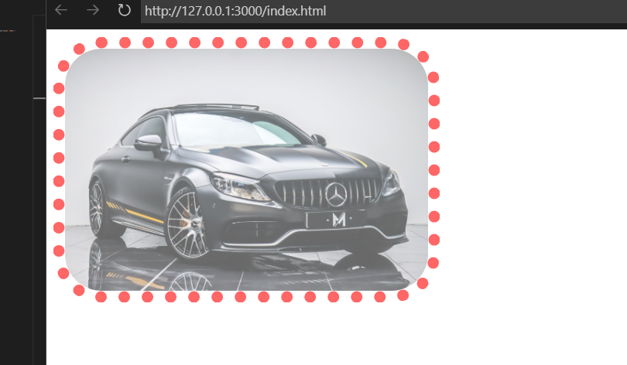
🖱️ Jab tum mouse le jaaye, tab image transparent ho jaayegi — stylish hover effect 😍

👻 Bonus – Text Pe Opacity
<p style="opacity: 0.3;">Yeh text halki si rooh ban gaya hai 👻</p>

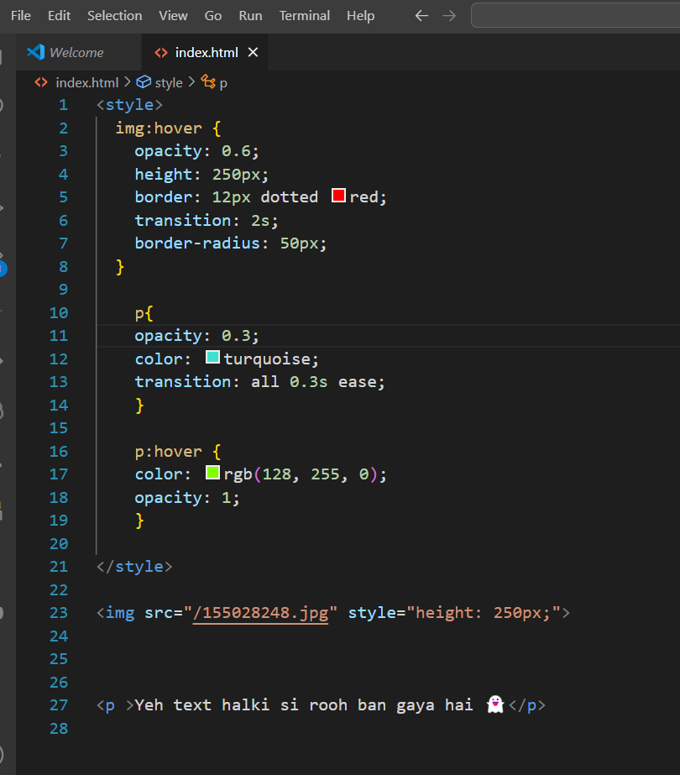
o/p



After Hover
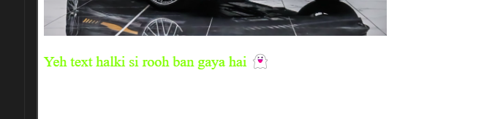

📝 Summary:
- opacity: 1 = Full visible
- opacity: 0.5 = 50% transparent
- opacity: 0 = Invisible
- opacity pura element pe lagta hai
- Background transparent chahiye = use rgba(…)
- Hover effect me super stylish dikhta hai 💅

